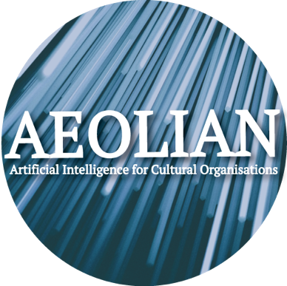
Application Form to attend the

AEOLIAN Network’s First Online Workshop:

Employing Machine Learning and Artificial Intelligence in Cultural Institutions

Wednesday 7th July from 12:00 to 17:30 GMT.
AEOLIAN (Artificial Intelligence for Cultural Organisations) is funded by the US National Endowment for the Humanities (NEH) and the Arts and Humanities Research Council (AHRC). The project is designed to investigate the role that Artificial Intelligence (AI) can play to make born-digital and digitised cultural records more accessible to users. AEOLIAN will make a ground-breaking contribution to this field through carefully-structured workshops, innovative research outputs, and the creation of an international network of theorists and practitioners working with born-digital and digitised archives.
The number of guests able to attend the workshop will be limited. If you would like to apply for a space at the workshop, please fill in the details below and send your completed application via email to: aeolian@lboro.ac.uk. Early-career professionals and academics, as well as post-graduate students and non-affiliated researchers, are encouraged to apply. You will be contacted to confirm whether your application has been successful or not. Please join the AEOLIAN JISC mailing list here.

Name

Contact email address

Affiliation / Employer / Independent Researcher

Location
Short bio (100 words max): Please explain your research interests, current or previous position and/or experience, and why would you be interested in attending this workshop.

Please note that all completed forms must be received by 18th June 2021.

